**ANALYSING HOUSING PRICES IN METROPOLITAN AREAS IN INDIA Introduction :**

**Since the inception of the theory and idea of development, the common feature that emerged in different point of time is the developmental gap that emerged in different parts of the world and also among various parts of a country in a particular time period. This disparity in development, like many other indicators, has also been reflected in India. Traditional development theories believed that agriculture, industrialisation, urbanisation, are significant ingredients of growth, and, ultimately important prerequisites for achieving development. Within the economy itself, the status of growth of a state can be judged through its performance in agricultural and industrial production, performance of service sector and urbanisation, and their impact through their contribution in income and employment generation at the national level.**

**House price behaviour may also reflect some short of developmental status of the households of a country. Keeping in view the above fact of rapid urbanisation and regional disparities, it is not unexpected that itmay lead to some sort of differences in regional house prices, where housing and real estate are considered as major sources of physical and financial asset.**

**PROBLEM DEFINATION &AND DESIGN THINKING**

**EMPATHY MAP:**

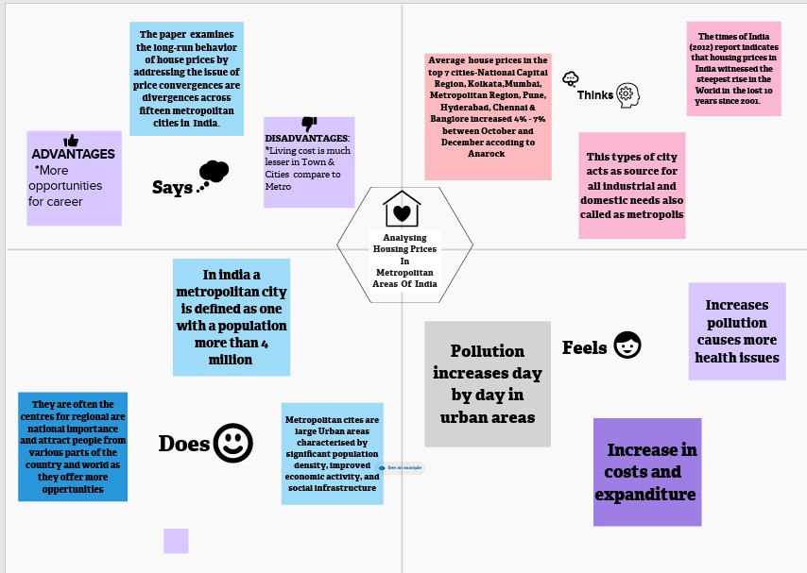

**EMPATHY MAP:**

* **Definition: An empathy map is a collaborative visualization used to articulate what we know about a particular type of user.**

**3.ADVANTAGES OF EMPATHY MAP**

* **More understanding of the Target Audience.**
* **More Organized Information in easy to understand format.**
* **Fast and Inexpensive.**
* **Easy Customization.**
* **Common Understanding and same mindset of whole team members.**
* **It describes what users think, say, feel, do.**

Limitations and Disadvantages

Empathy Maps they are designed to capture the needs and perspectives of a specific audience, but may not capture the needs and perspectives of other stakeholders. For example, an empathy map created for customers may not capture the needs and perspectives of employees or supliers.

**IDEATION&BRAINSTORMING MAP:** 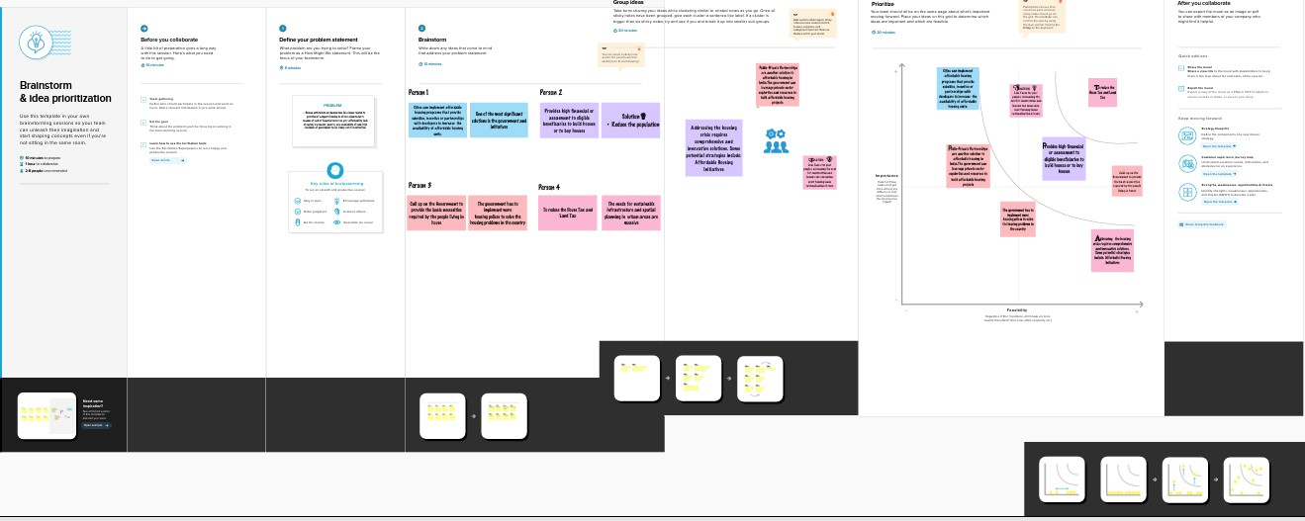

**BRAINSTORMING:**

by gathering Brainstorming is a group creativity technique by which efforts are made to find a conclusion for a specific problem a list of ideas spontaneously contributed by its members. A group of people write ideas on sticky notes as part of a brainstorming session.

ADVANTAGES OF BRAINSTORMING:

* **Provides a quick and easy class activity. ...**
* **Contributes to classroom collective power. ...**
* **Creates a student-centered activity. ...**
* **Supports learning in a relaxed environment. ..**

**DISADVANTAGES OF BRAINSTORMING:**

**However, there are some disadvantages to brainstorming. For example, getting the right people (especially senior staff) to attend can be difficult, meaning some critical perspectives may be missed. Group dynamics can also influence the outcome, and strong individuals often dominate the session.**



***CONCLUSION:***

***CREATING DASHBOARD,STORY USING TABLEAU AND ANALYSING HOUSING PRICES IN METROPOLITAN AREAS IN INDIA***

**SHEET1**

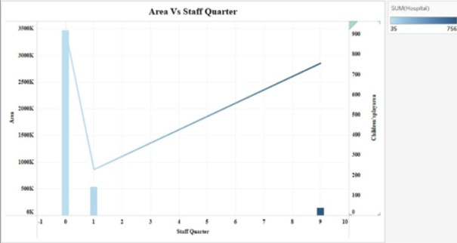

***SHEET2***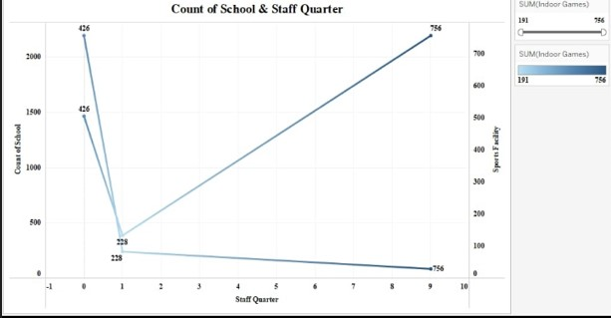

**SHEET3**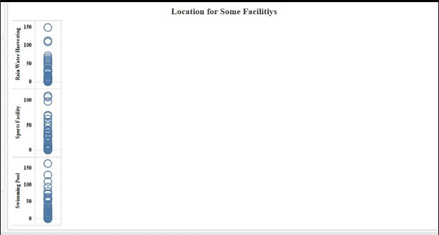

**SHEET4**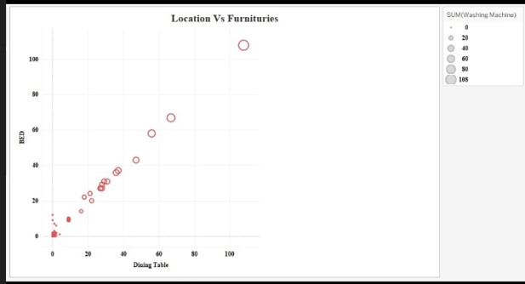

**SHEET5**

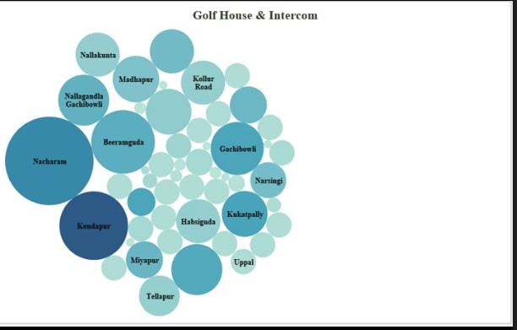

***SHEET6***

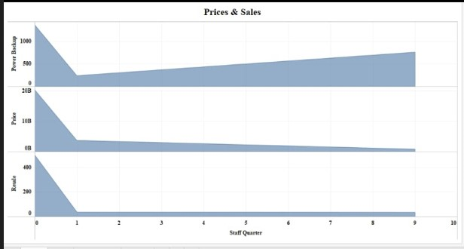

***SHEET 7***

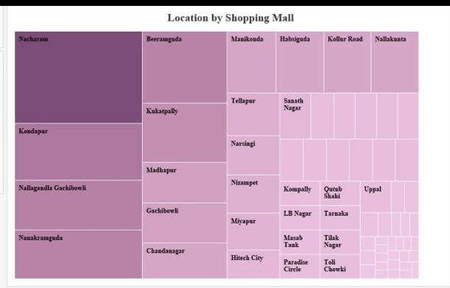

**DASHBOARD**

**ANALYSING HOUSING PRICES IN METROPOLITAN AREAS OF INDIA**

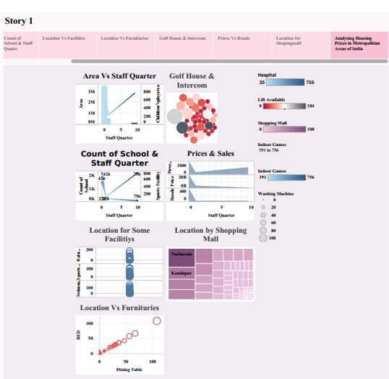

**STORY**

**ANALYSING HOUSING PRICES IN METROPOLITAN AREAS OF INDIA**

**SHEET 1**

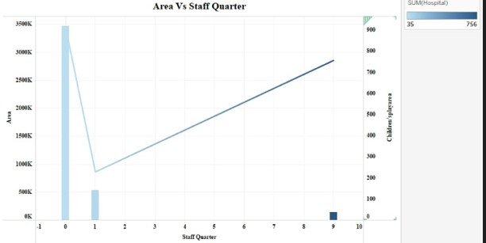

***SHEET2***

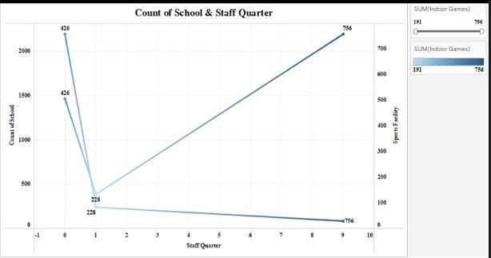

***SHEET3***

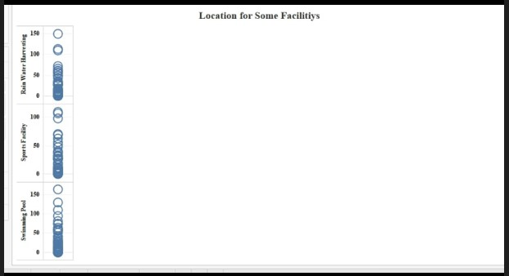

***SHEET4***

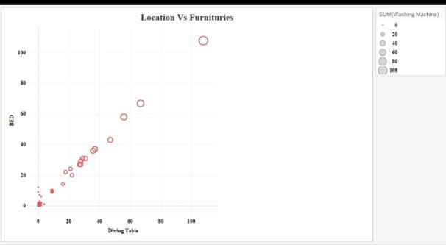

***SHEET 5***

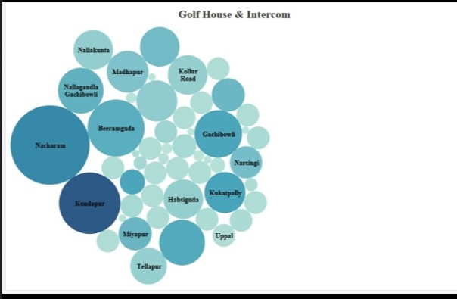

***SHEET6***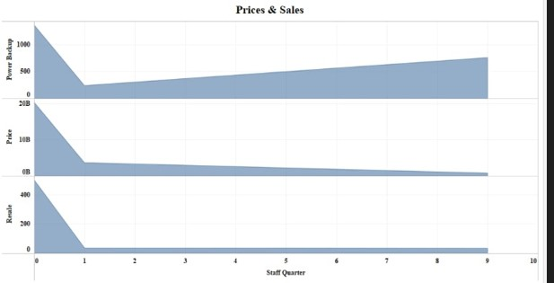

***SHEET7***

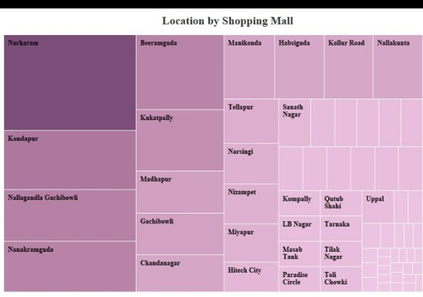

**ANALYSING HOUSING PRICES IN METROPOLITEN AREAS OF INDIA**

**Submitted by:**

**R. PARAMESHWARI**

**M. MAHA**

**V. MENAKA**

**M. MANISHA**